Data Structure is a way of collecting and organising data in such a way that we can perform operations on these data in an effective way.

For example, we have some data which has, player's name "Virat" and age 26. Here "Virat" is of String data type and 26 is of integer data type.

Basic types of Data Structures

As we have discussed above, anything that can store data can be called as a data structure, hence Integer, Float, Boolean, Char, etc. all are data structures. They are known as **Primitive Data Structures**.

Then we also have some complex Data Structures, which are used to store large and connected data. Some examples of **Abstract Data Structure** are:

* Linked List
* Tree
* Graph
* Stack
* Queue

All these data structures allow us to perform different operations on data. We select these data structures based on which type of operation is required. We will look into these data structures in more details in our later lessons.

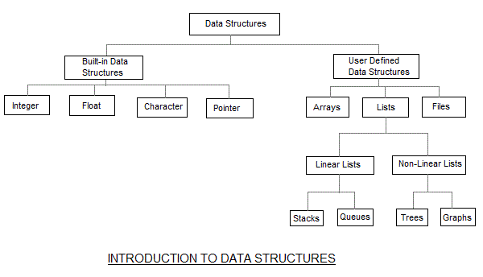

Array: An array is a collection of items stored at contiguous memory locations. The idea is to store multiple items of the same type together. This makes it easier to calculate the position of each element by simply adding an offset to a base value, i.e., the memory location of the first element of the array (generally denoted by the name of the array).

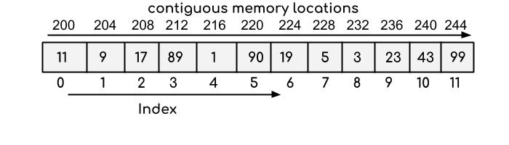

Linked list: Like arrays, Linked List is a linear data structure. Unlike arrays, linked list elements are not stored at a contiguous location; the elements are linked using pointers.

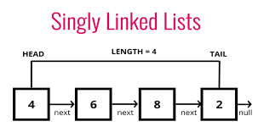

Stack: Stack is a linear data structure which follows a particular order in which the operations are performed. The order may be LIFO (Last IN First Out) or FILO (First IN Last Out).

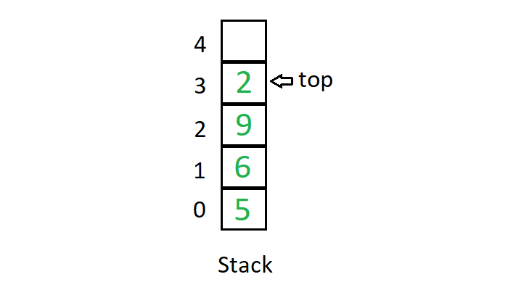

Queue: Like Stack, Queue is a linear structure which follows a particular order in which the operations are performed. The order is First IN First Out (FIFO). A good example of the queue is any queue of consumers for a resource where the consumer that came first is served first. The difference between stacks and queues is in removing. In a stack we remove the item the most recently added; in a queue, we remove the item the least recently added.

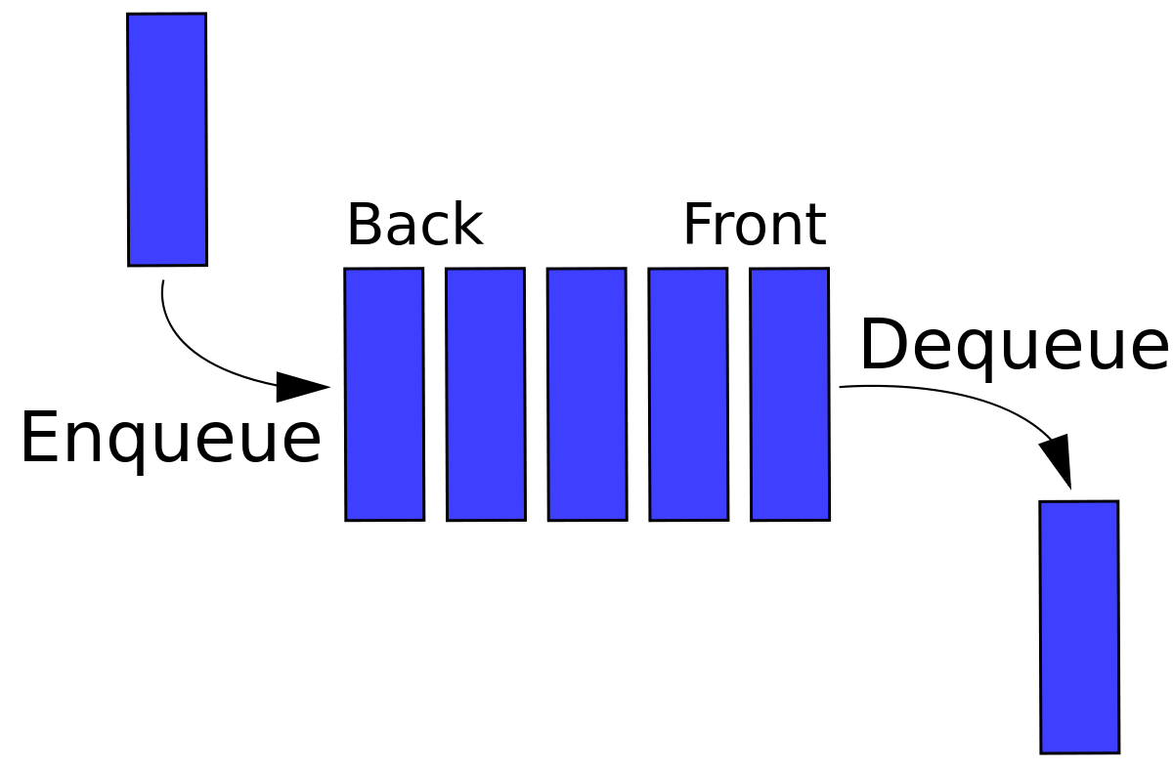

Hash Table: Hashing is an important Data Structure which is designed to use a special function called the Hash function which is used to map a given value with a particular key for faster access of elements. The efficiency of mapping depends on the efficiency of the hash function used.

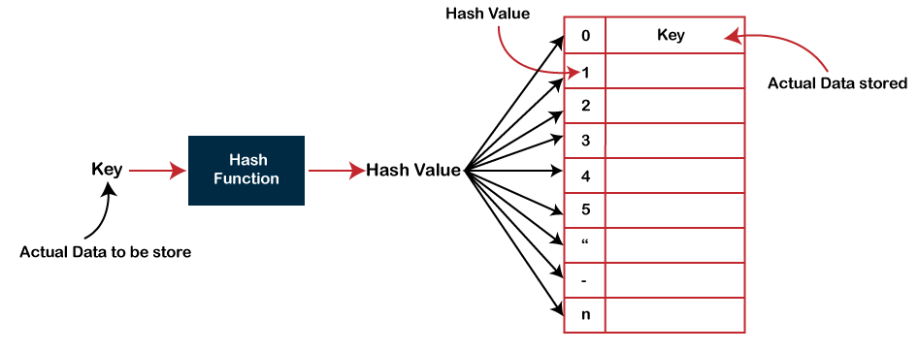

Trees: Unlike Arrays, Linked Lists, Stack and queues, which are linear data structures, trees are hierarchical data structures. A binary tree is a tree data structure in which each node has at most two children, which are referred to as the left child and the right child. It is implemented mainly using Links.

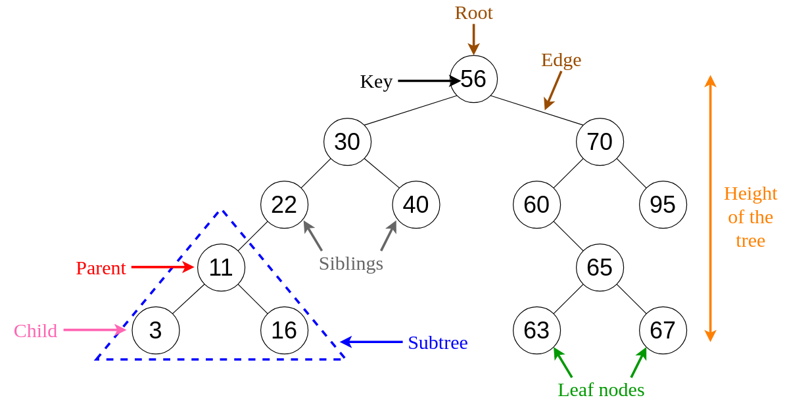

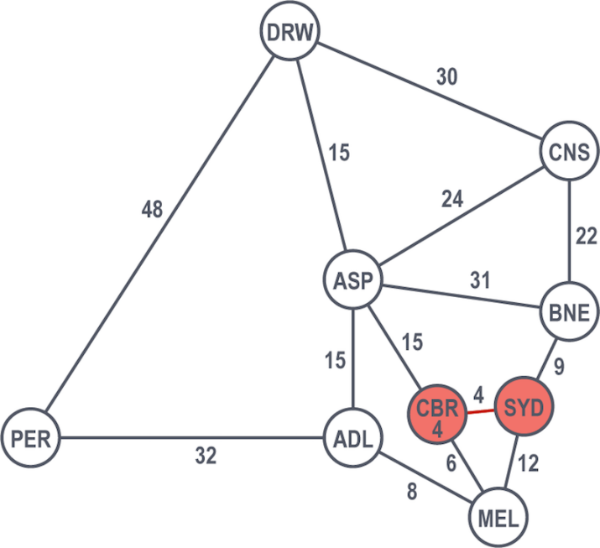**Graphs:** Graphs can be defined as the pictorial representation of the set of elements (represented by vertices) connected by the links known as edges. A graph is different from tree in the sense that a graph can have cycle while the tree can’t have the one.